Seed Grant Proposal Attachment
Project Title: Design of IOT Architecture for Battery Charging Management System
Problem Statement:
- The future Expansion of EV Charging Infrastructure requires significant enhancements to charging infrastructure to meet growing demand and ensure grid stability.
- The Power Grid Stability Challenges in Current EV charging systems can create sudden load disturbances on power grids, leading to potential stability issues, particularly during peak demand times.
- There is a critical lack of real-time and predictive data regarding power demand, complicating energy management and efficient load balancing.
- The high installation and operational costs of charging solutions, combined with inefficient load management and limited grid capacity, hinder the broader adoption of EVs.
Objectives:
- Design and implement IoT architecture for a Battery Charging Management System that includes remote monitoring and control capabilities.
- Integrate renewable (solar) and non-renewable energy sources (grid power) to ensure a stable and reliable energy supply for charging operations.
- The real-time data processing to enhance load management, minimize power grid disturbances, and enable automated charging control based on solar generation and energy storage status.
- The user-friendly interfaces for remote management of charging stations while optimizing energy savings and achieving approximately 88.6% energy efficiency through effective integration of energy sources.
Methodology:
- Design Phase
- Integration of renewable non-renewable energy sources, energy storage systems (ESS), and grid power to create a stable charging infrastructure, including a Point of Common Coupling (PCC) for automation.
- Stabilizing a battery swapping station along with four units of DC fast charging stations to enhance charging options and efficiency.
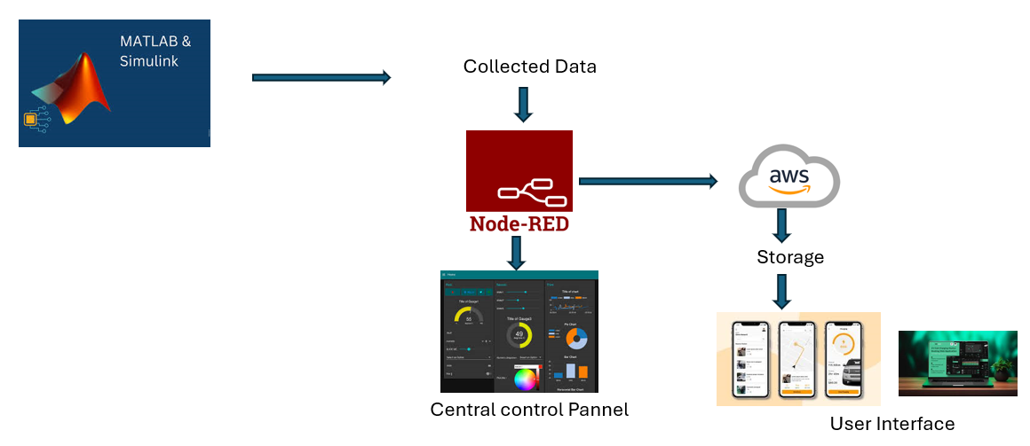
Figure 1: Design flow of the proposed methodology

- Simulation Phase
- Worked on simulations in MATLAB, achieving an energy efficiency of 88.5%. Connect MATLAB sensor data to Node-RED for effective data monitoring and control.
- Send the required data to AWS for storage in S3 buckets, utilizing email alerts and QuickSight for remote data visualization.
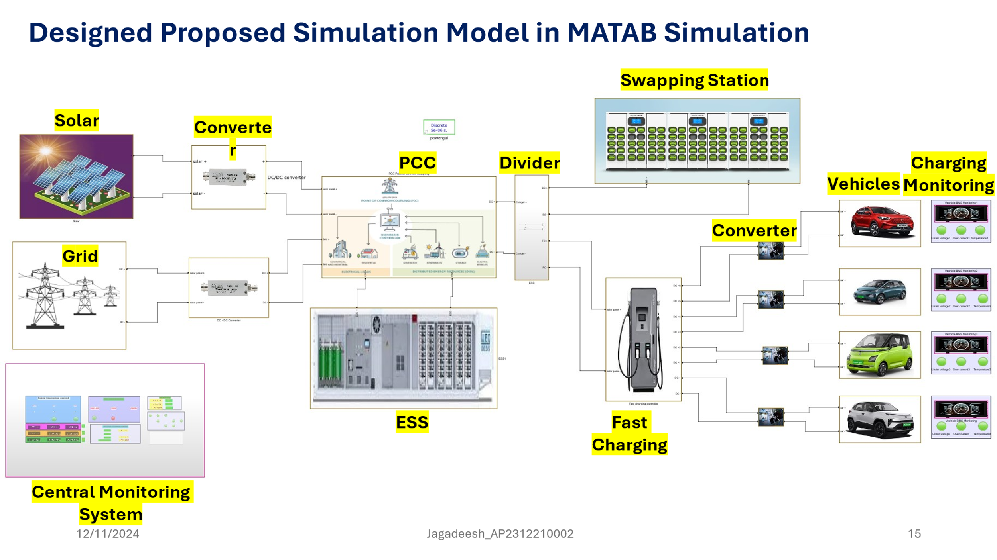
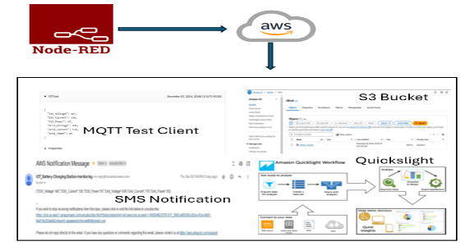

AWS Integration
Node-Red
MATLAB Simulation

Figure 2: Simulation flow of the proposed work.

- Hardware Prototype Phase
- To take simulation work to hardware, to address Realtime faults and Realtime data collections.
- Implementing IOT architecture for Battery charging Infra Technology.

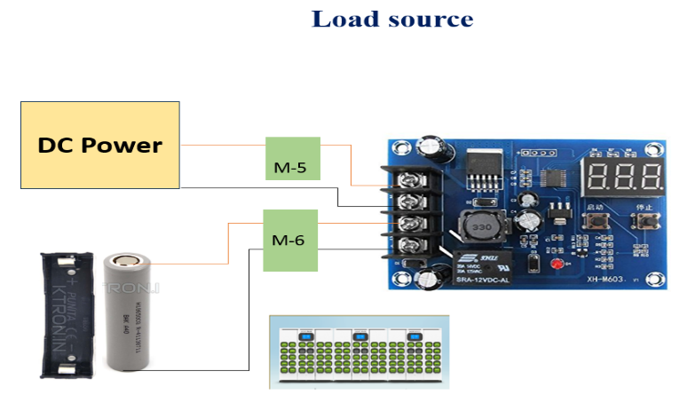
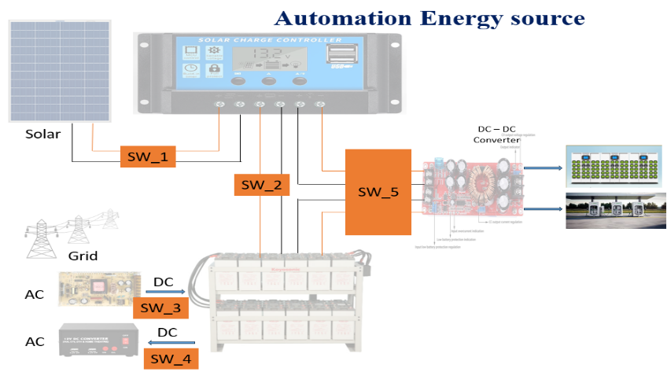

Swapping charging setup
Hardware setup

Figure 3: Hardware implementation of the proposed work.

Outcomes:
- Prototype Development
- Design patent or Publication

Benefits of the project:
- EV Charging infra-Prototype is available for future research projects.
- With this prototype will get Real-Time data.

